Software engineering for AI

techniques

\*Lab assignment\*

NAME: T. ASHWATH

REG NO: 192011375

DAY: 01

FACULTY NAME: DR.G.MARY VALANTINA

1. Draw a USE-CASE diagram for Online Voting System using CASE tools

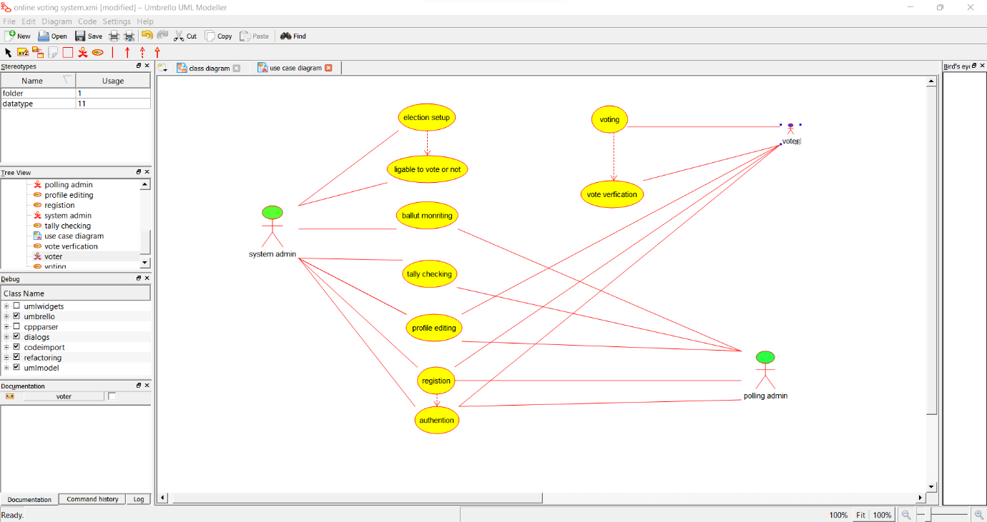

2.Draw a USE-CASE diagram for Library Management System using CASE tools.

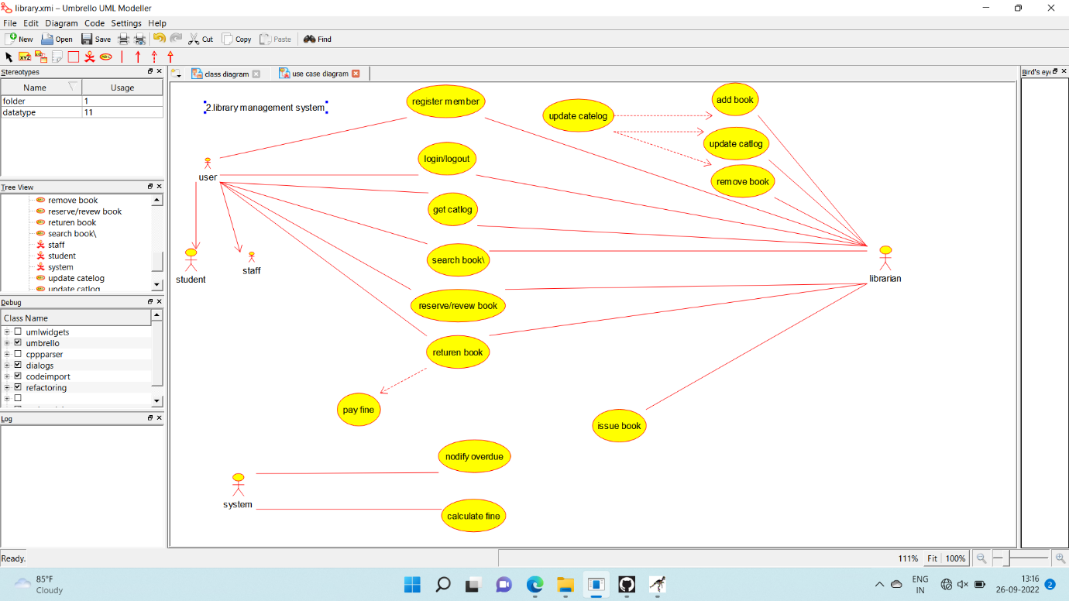

3.Draw and validate the flowchart to compute the quotient and remainder

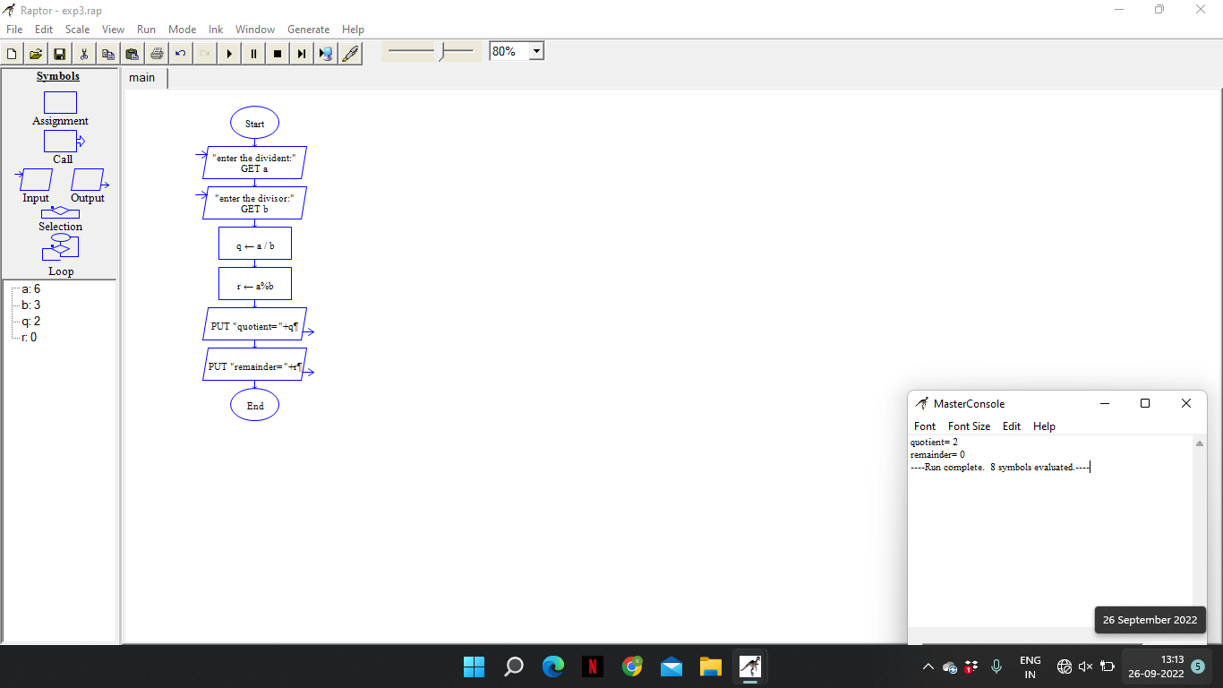

4. Draw a USE-CASE diagram for Online Shopping system using CASE tools

